Chastity’s Chess Chapters

An ongoing chess book project for those who have falsely heard that chess is hard to learn

Introduction

I learned to play chess when I was 9 years old. My friend Patrick taught me, and I won the third game. He said he created a monster. Up to that point, I had always heard that chess was complicated. After learning the game, I struggled to find other people to play with. You have to remember that at that age I didn’t have the internet.
The internet changed the game because you no longer need to wait for another human in your town to play with. You can set up matches with random people on lichess.org, chess.com, and even Facebook. If all else fails, you can download a chess program and play against the computer using some of the best chess engines available.
However, I will warn you that playing against a computer comes with pros and cons. Most computer programs will tear apart a player new to the game unless they are set to the lowest level AI. It can be discouraging to new players who lose twenty games in a row and then think, “I guess I am really bad at chess,” and then get discouraged and quit playing.
Chess is a game where you are going to lose half the time because it’s a game of pure skill where anyone can win if they can outsmart their opponent. You don’t need to be a genius to play chess, and you certainly don’t have to know math or memorize opening theory to get started playing today. You only need to know the rules of chess, which can be learned in less than half an hour.
The book you are reading now is meant to teach the rules and be a reference to look back on if you forget. I will also include some common suggestions on a few good ways to get started playing and what your first moves should be as a beginner.

Chapter 1: The Basic Rules of Movement

Hello, I am Chastity White Rose and I am a chess player. I am one of many people who love the game of chess because it is one of the best games for playing with other people and understanding how their mind works.
The actual rules of chess are not very hard to learn. There are 6 types of pieces, and they have very specific rules of how they move that never change. Compared to the complexity of most video games that people play, chess is actually very simple because there is a lot less to learn and remember. If you have played Pokemon, Final Fantasy, or Tetris, then you are smart enough for chess!
But chess is not specifically a video game. It’s a board game that has only recently turned into a video game because there are chess programs for every machine you can imagine. You can play from a regular Personal Computer or a Smart Phone these days and play with other people all over the world through the internet. Later on, I will talk about some of the best sites to play chess online.
But first, a basic explanation of the goal of chess. The way to win the game of chess is to checkmate the opponent’s king. Checkmate means that you are attacking the king and it has nowhere to move to escape and would be captured on the next turn. I will show examples of what this looks like later on.
For now, I intend to teach you the basic rules of how each piece moves by isolating them from the other pieces and highlighting the empty squares they can move to by highlighting those squares in green. Just think “green means go,” as in a traffic light.
Below is a picture of what the chessboard typically looks like if you are playing on a computer chess program. This is how the pieces are arranged. The chess set used is called Merida and it is one of the piece sets available on lichess.org where I play chess online.

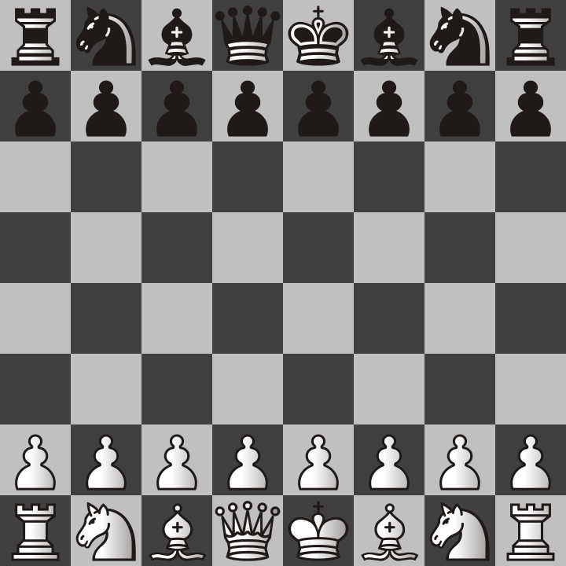
I will explain the names of each of this pieces and how they move on future pages.
The first piece that you will want to learn is the pawn. The pawns are the most abundant piece on the board and each side (black and white) has 8 of them to start with. They only move in one forward direction (away from the side they started on)
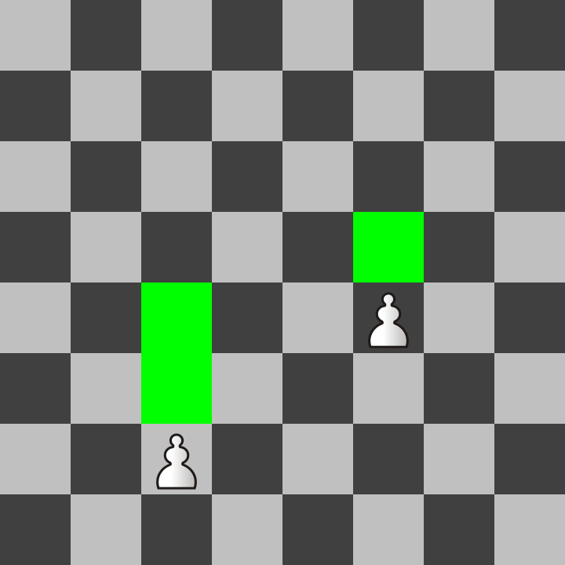
Pawns can move one square forward except that they can also move two spaces on their first move. Notice that the left pawn is in it’s starting position and has not moved yet, so it can move to either square in front of it highlighted in green, but only on this first move.
Pawns capture other pieces differently than the way they move onto empty spaces. They capture only one diagonally forward. Consider the following image:
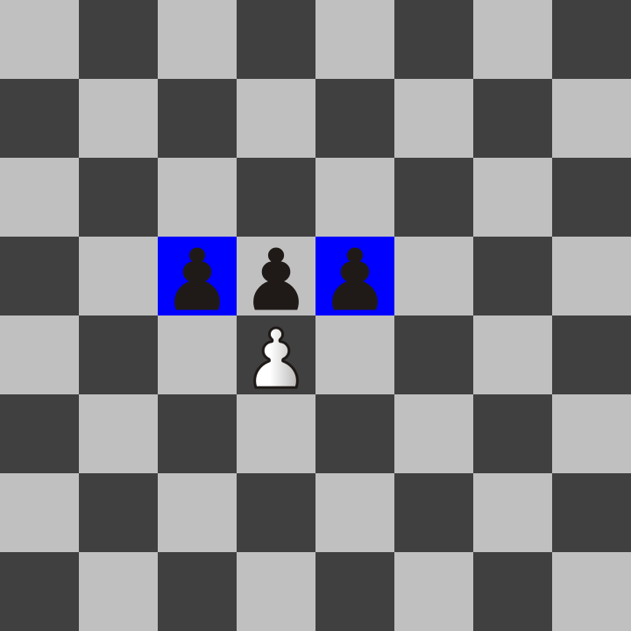
The white pawn can capture either of the two black pawns on the blue squares because they are diagonally one space in front. Notice that the white pawn cannot capture the pawn exactly one space in front. It only can move that way if the square is empty.
The previous two pages contain everything you need to get started with moving pawns. There is another rule called en passant that I will cover later in the special rules at the end of this chapter because it is quite rare to see. The main thing right now is to learn how each piece moves. Also, I want to explain my convention of how I use color in this book.

Green Squares are for empty spaces which a piece can move onto. I will use them as illustrations of how each piece moves in the pages following this page.

Blue squares are for showing when a piece can capture other pieces on those squares.

Red squares may be later used to explain spaces that a king cannot move onto because he would be in check and could be captured. Remember, if the king is captured, then the game is over, and whoever captured him wins.
Unlike the pawns which have a special capturing rule different than how they move onto other spaces, every other piece moves and captures the same way.
For this page and the next four pages, I will show the movement rules using a single piece on the board and highlight all the squares in green where that piece can move.

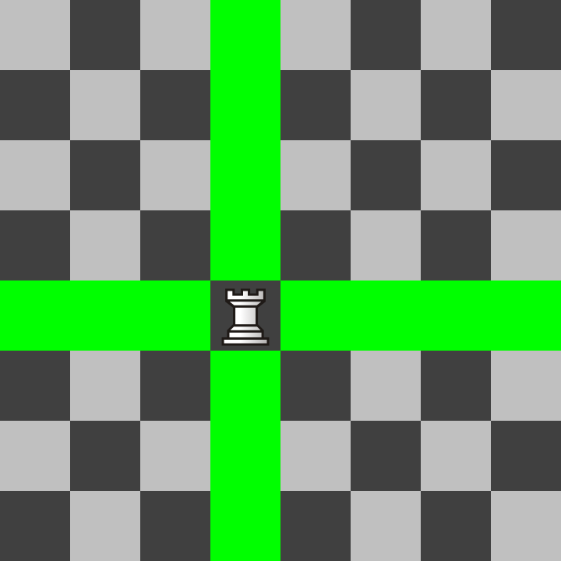
The rook moves orthogonally. That means it can move up/down and left/right as many squares as it wants. If there are any pieces on those squares, it captures the first one it hits and then stops.
The bishop is the opposite of the rook because it moves diagonally.

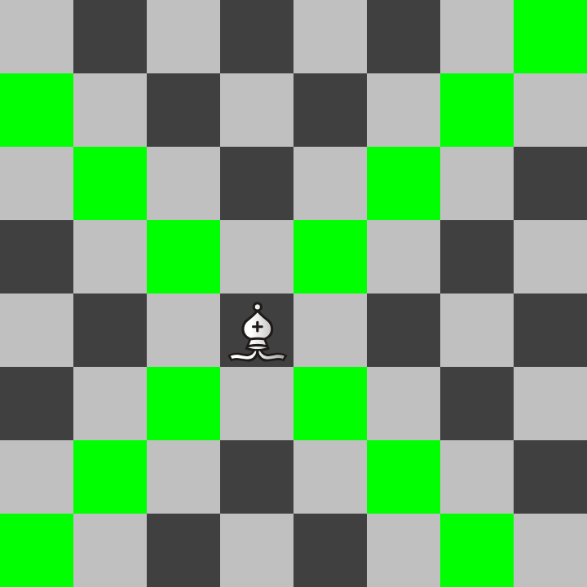
Notice that because of this, a bishop can only move onto 32 of the 64 squares on the chess board and always remains on the same color as what it started on. Remember, all official chessboards have light and dark squares of the checkerboard pattern.
Next, I will introduce my favorite chess piece. It is called the knight, but it actually looks like a horse. It moves in a way that is called hippogonally. As it turns out, hippo actually means horse, and the hippopotamus means river horse. The knight is called a knight because knights often rode horses in battle. In older chess versions, it was simply called a horse.
The knight has an unusual form of hippogonal movement. It jumps over other pieces but in a shape that looks like an L Tetris block. It may seem odd to describe it, but I will have a picture on the next page that includes an example of how a knight moves.
But before that, I want to give my answer to the ancient debate between chess players over whether the knight or the bishop is a more powerful piece. If you are going to lose one or the other, each player has their preference of which to protect.
My personal opinion is that the knight is more valuable. It is not as easy to checkmate with as other pieces, but I protect mine religiously because it is the ONLY piece that can simultaneously attack 8 pieces at one time. Because this piece is special, I will have to show some examples later on of how to use it effectively.
See the image below to get an example of all the places a knight can jump to. It can move to 8 spaces if it is near the center of the board. It moves 1 square orthogonally and then one square forward diagonally from that direction.
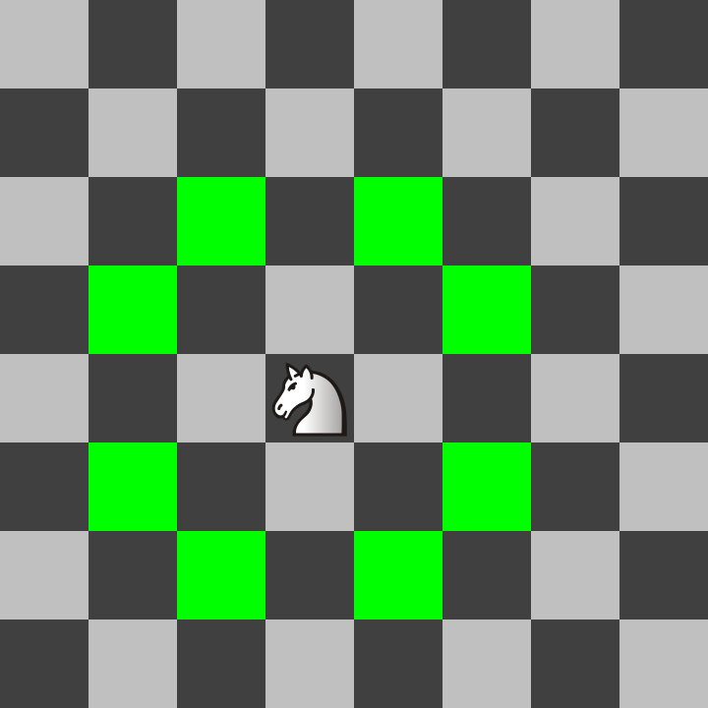
This movement of jumping over other pieces is unique to the knight. Using it effectively is the challenge because it is harder for new players to visualize it. Consider coming back to this page for a visual reminder of it.
The queen is the most powerful piece in the game because she has the combined powers of a rook and a bishop! See below the example of all the places that queen can move to!
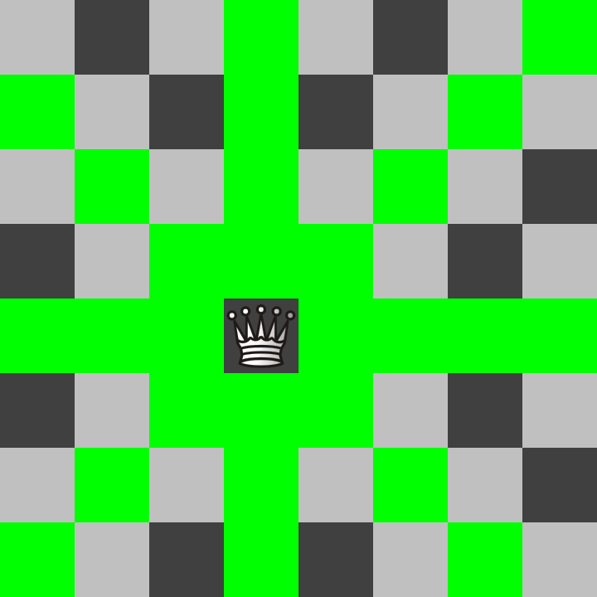
As you might guess, the queen is usually what people rely on to win the game and players try to avoid losing the queen. She may only be a single piece but can wipe out an army unless the opponent has a plan to stop her!
The king is exactly like a queen but it can only move one square in any of the 8 directions. It is also the most important piece that decides who wins or loses the game. If the king is being attacked and cannot move to a legal square, that player who owns the king loses the game.

See the next page for an example of what a checkmate may look like.
In this image we see that the white queen is directly next to the black king. The black king has only one empty square that it could move to but the queen attacks that square and would still capture the king.
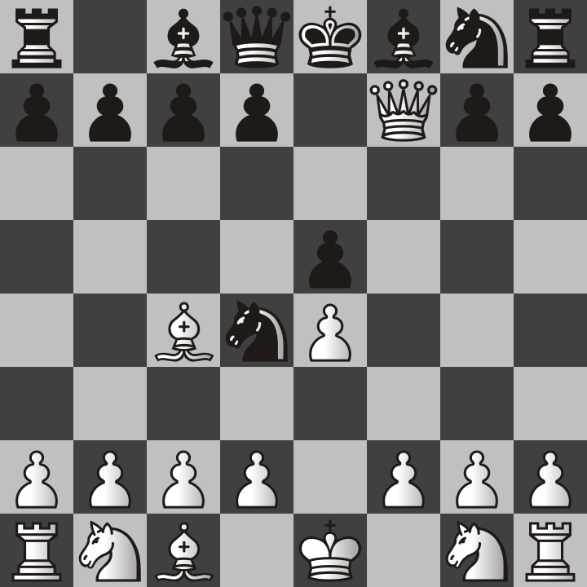
You may wonder why the king can’t simply capture the queen. That is because then the bishop would then capture the king. Two or more pieces can easily gang up on a king and then it is game over. There are times however when only one enemy piece can checkmate the king if that king is blocked by its own pieces.
Consider the following image of a checkmate that is shown from black’s perspective. If you are playing the black pieces, they will be closer to you. That is to simulate what it would look at from above on a real chessboard.
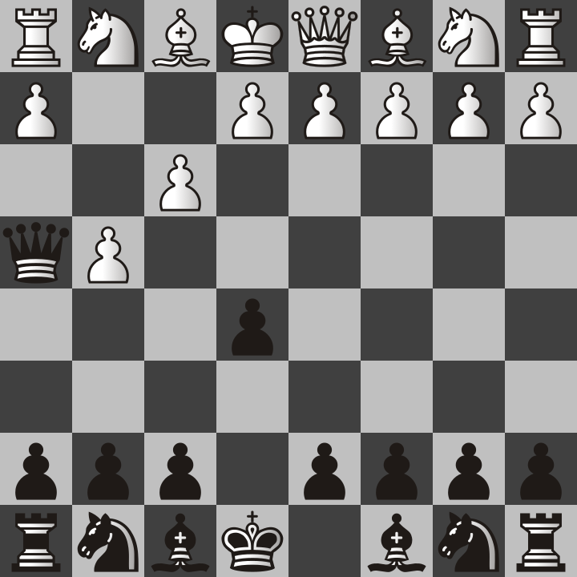
In this picture, you can see that white moved two of its pawns, and black also moved its queen over so that it is in direct diagonal direction from the king. This is checkmate because the white king is blocked by its own pieces from moving to a safe spot. It also cannot move anything in the way.
This form of checkmate is called the fool’s mate. It only happens if white is being a fool and traps themselves. Normally, you would not want to move those pawns unless you had already given yourself an escape route or moved other pieces that could resist the queen's attack. The fool's mate is more common than you think and I include it so that you don't fall into it.

Now you know all of the most important rules of chess to get started with. There are two more rules called castling and en passant. However, I think it is best to get started playing chess and then learn about those rare cases later on. In the next chapter, I plan to show examples of what your first moves might be to get the game started. You can choose any legal move at any time it is your turn in the game of chess, but some moves are more likely to be successful than others. The previous example of the fool’s mate shows what pawns you may not want to move right at the start of the game.

For now, remember that you can get started playing chess today! To get started playing online I recommend lichess, the world’s best free chess server with no ads. Go to the following link and there are interactive lessons that allow you to practice moving the chess pieces.

https://lichess.org/learn

In fact, the depth of learning tools they offer you is far beyond what I have included in this chapter. However, I wish to point you in the right direction to a site you can use that will not scare you away with telling you to buy a premium membership or show ads constantly advertising products like Viagra, Burger King sandwiches, or laundry detergent. Nothing is worse than being distracted when you are trying to learn the number one board game in the world.

Playing chess online is a good way to get started because it is unlikely that you will have another person available 24/7 willing to play with you at a time that is convenient for you.
Also, lichess does have a mobile app for cell phones but I recommend starting on a regular desktop or laptop PC because using a mouse is much easier than tapping on a tiny cell phone screen. It can be done but the chance of mistakes is higher.

Try practicing playing a few games and then continue to the next chapter to see my personal suggestions on starting moves to help you have a chance at winning more often.

Also, if you find yourself liking the game of chess, I do recommend creating an account on lichess because then you can challenge anyone or add them as a friend. Lichess is not just a site for playing chess, it is an entire social network that also keeps track of all your games so that you can look back and see what went wrong.

Below is the link to my profile:

https://lichess.org/@/chastitywhiterose

Send me a challenge any time and I will respond when I am available. My challenge is to teach people about the game of chess and help them improve so that they can beat me. That way, even if I lose the game, I still win as a teacher.

On the next few pages, I will explain the en passant and castling rules.

En Passant

Because of the fact that a pawn can move two squares on its first turn, there is a special rule called en passant which allows the opponent’s pawn AS IF it had moved only one. Consider the following picture. The black pawn just moved two squares from it’s starting position. The blue square is where the white pawn can move to and capture the pawn “in passing” (which is what “en passant” means in french).
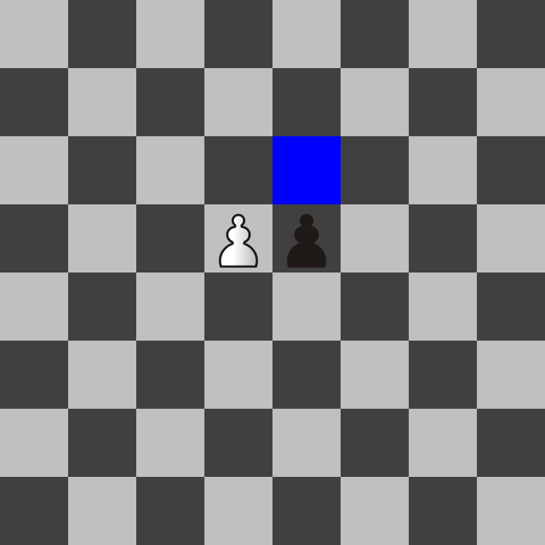

The idea is that the pawn would have captured the pawn while it was moving through that square. This is to compensate for the limitations of a turn based game. Don’t worry though, this rule only applies to pawns and only on the turn immediately after a pawn has moved two squares last turn.

Castling

Remember when I said a king only moves one square at a time? Most of the time this is true. Although this makes no sense, there is a rule that allows a king to move two squares in one turn. Consider the setup below.
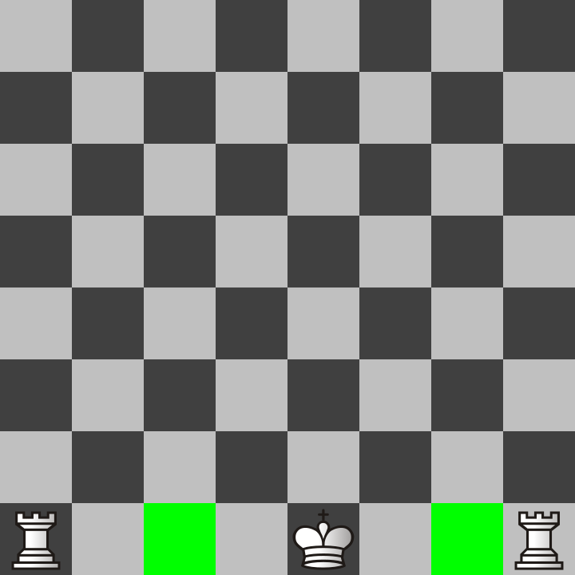

Because there are no pieces in between the king and rooks and because the king and rooks have not moved in this game, they are allowed to do a one time “castle” move where the king and the rook both move. The king moves two spaces towards the rook and then the rook goes to the square the king skipped over!
King side castle
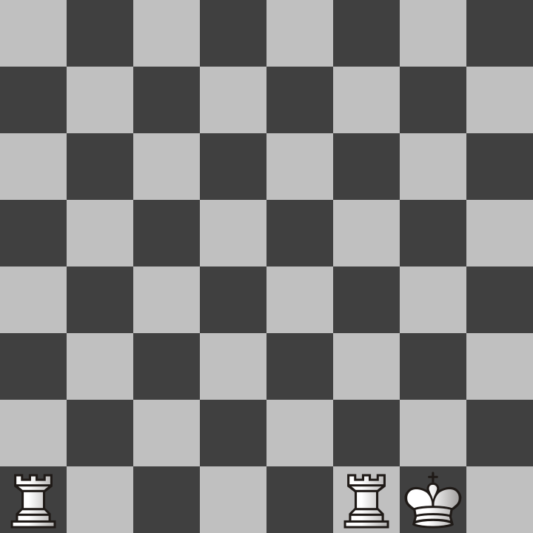

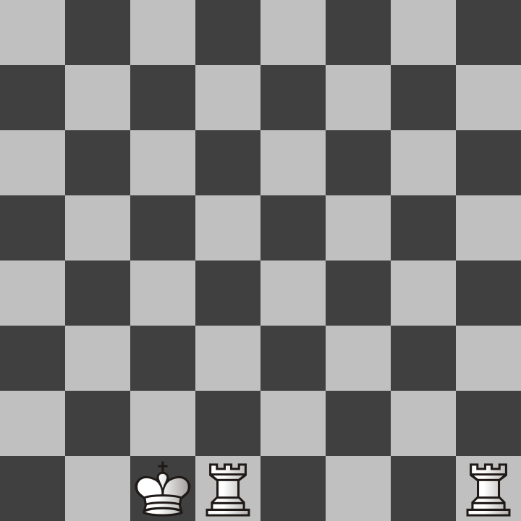
Queen side castle
Don’t let these special rules confuse you too much. They are a bit nonsensical. In fact I would compare them to the T spin triple rules in Tetris. On a related note, Tetris is actually a really good game too. Tetris is my favorite video game but it is not as easy to play as chess because Tetris requires quick reflexes and planning in mere seconds.

Chess is more of a game for slow careful thinkers. Although there are some who play speed chess, I don’t recommend trying to play fast for beginners. Focus on quality of moves rather than how many moves you can make in a minute. Also, play without time limits or choose time limits that are reasonable. I play 30 minute live games against other people online and my rating for classical chess is higher than rapid, blitz, or bullet chess for that reason.

Time limits are artificial inventions made for convenience of society. Don’t rush through chess they same way everyone in society forces you to be fast and cause accidents in the real world. I work at Walmart so I know exactly what happens when employees are rushed. Products get put in the wrong spot and injuries happen if people value only speed and forsake everything else.

Chess, or any game for that matter should be for fun, not as a job you do because someone else is forcing you to. No matter what, you must remember that!

Chapter 2: The First Moves

For the sake of keeping this book short, I will not be trying to teach all details about chess notation. Part of this is because I don’t want to explain it wrong. However, all the major chess sites including lichess do keep track of the moves you play in every game and will show you the chess notation. It’s actually very easy to pick up just by looking at examples from your own games. I will be calling moves by their chess notation name but every almost every move will also have a picture with it so that there will be no confusion as to what it means.

White takes their turn first in the game of chess. This means that if you are playing as white, you have the unique opportunity to pick the first move that will set the course of the rest of the game! However, there are only a few moves that are considered to be very good. I will show you the two most popular choices that white players use to start the game.

But first, I have an example image that shows the names of all the squares in chess notation. Take a look at the next page.
Below you will see an image that has all the letters and numbers of each square from the white player’s perspective. Look back at this picture because it will help explain a lot of what I mean in the pages after it.
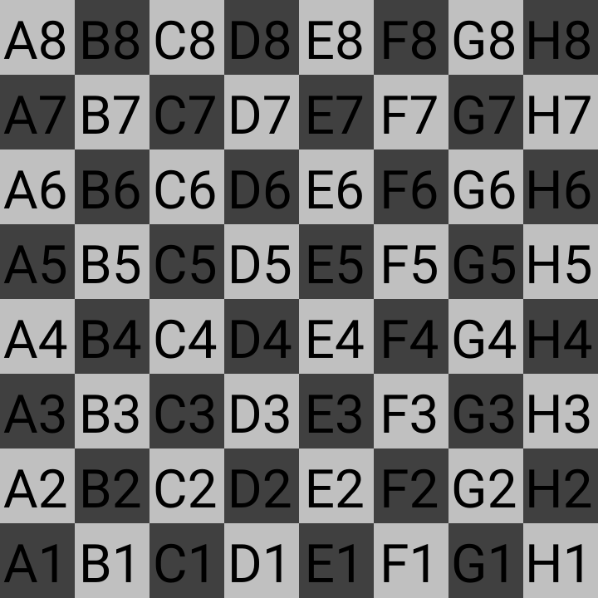
Square E1 is where the white king starts the game and E8 is where the black king starts the game. Also look at squares F2 and F7 because those are the squares most vulnerable to attacks that put the king in check. Moving those pawns at the beginning of the game is asking for trouble!
The first and most popular is e4 (white’s king pawn two squares forward)
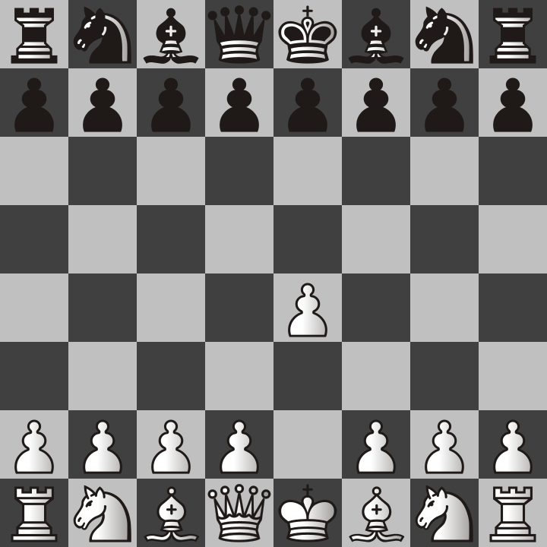

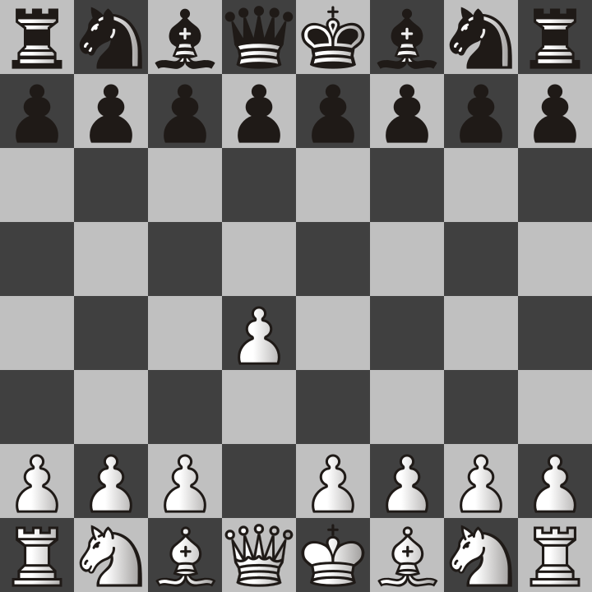
The main reason e4 is a popular move is because it allows white’s queen or bishop to get out on the next turn white plays. Most chess masters consider it to be the best move and it is also commonly played by chess engines. But it’s not the only popular move. The second is d4 (white’s queen pawn two squares forward)
Moving this pawn to d4 is popular because it is the start of many different openings that involve getting the dark squared bishop out early in the game. This could be the start of the Queen’s Gambit, Trompowsky Attack, or the London System.

But that isn’t to say there aren’t countless openings that begin with the first and most popular choice I mentioned earlier. If you are playing white, you should decide which of these moves to start with and then you should start with it every time until you get used to seeing how your opponent moves and how they respond to each of your moves. That’s not just my advice but is the advice of chess coach Levy Rozman (GothamChess) who I learned a lot from!

Although studying openings is fun, don’t rely on them so much that you find yourself lost as soon as your opponent does something unexpected. That being said, you should probably have a plan for the first 4 moves at least. Planning ahead requires some experience of playing, winning, and losing games to see what worked and what didn’t.

I find that I win my games more often when I start with e4, but I find myself having more fun when I play d4 as my first move and then try for the Queen’s Gambit, which is my favorite. I will be explaining the Queen’s Gambit opening later on but first I am going to show you the most generic ways to start the game. This will mostly be from white’s perspective but you will find that this method is flexible enough to be mirrored for both players.

The Bishop’s Opening

First, both white and black move their e file pawns two squares for their first move.
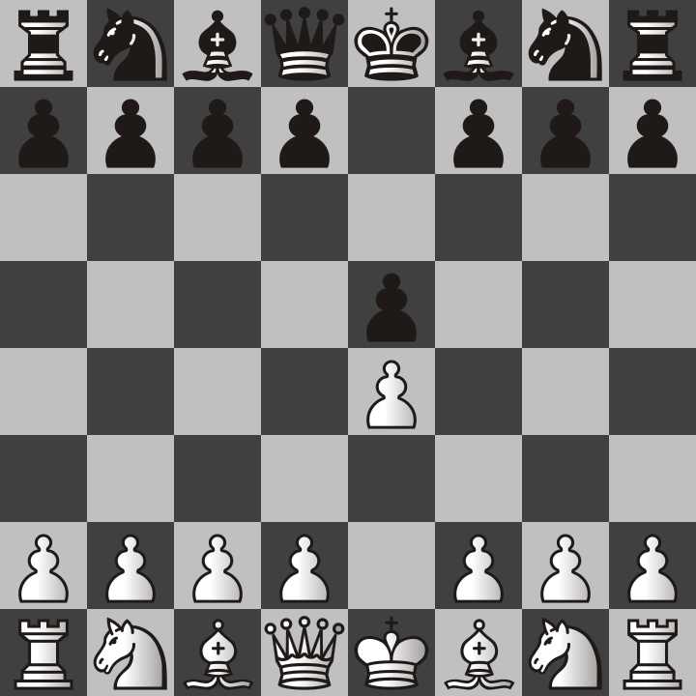

This is equally good for both of them because that allows both of them to get their bishops or queens moved out diagonally. Keep in mind that at the beginning of the game, diagonal moves are faster than orthogonal moves. The rooks can’t get out because the pawns in front of them are blocking their movement. For this reason, your early attacks will depend on bishops.
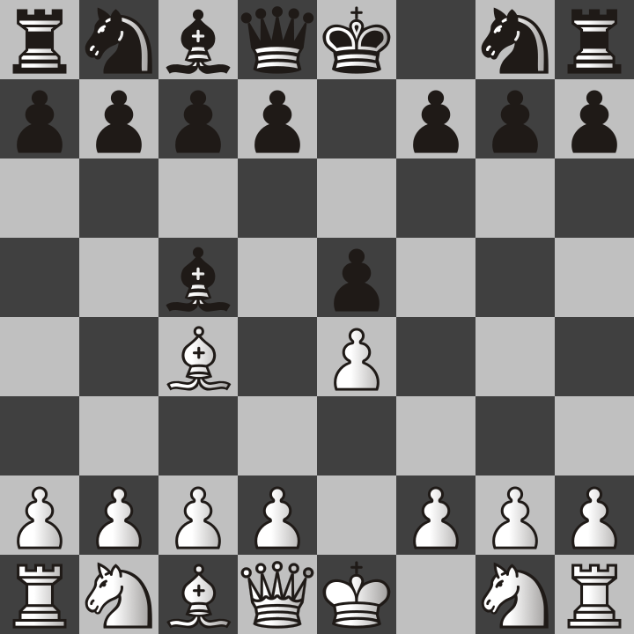

Next, the bishops come out. This means they are both attacking the weak F2 and F7 squares I mentioned earlier. This position is called the bishop’s opening for obvious reasons.
If you find yourself in the bishop’s opening position, you have some serious options to consider. If you are playing white, you already have an advantage in this position because it is your turn. You could move the knight to F3 and attack the e5 pawn or you might want to move the queen to H5 and try a scholar’s mate.
Keep in mind that the possible moves your opponent can do are endless and that to a certain extent, to show an example, I have to make up possible moves of only one of them just to prove the point I am showing. There is no way of knowing if you will end up in the mirrored bishop setup as shown in the previous image. With that being said, if you EVER DO find yourself in this exact position, I will show you some great possibilities that can come from it. I recommend knight to F3.
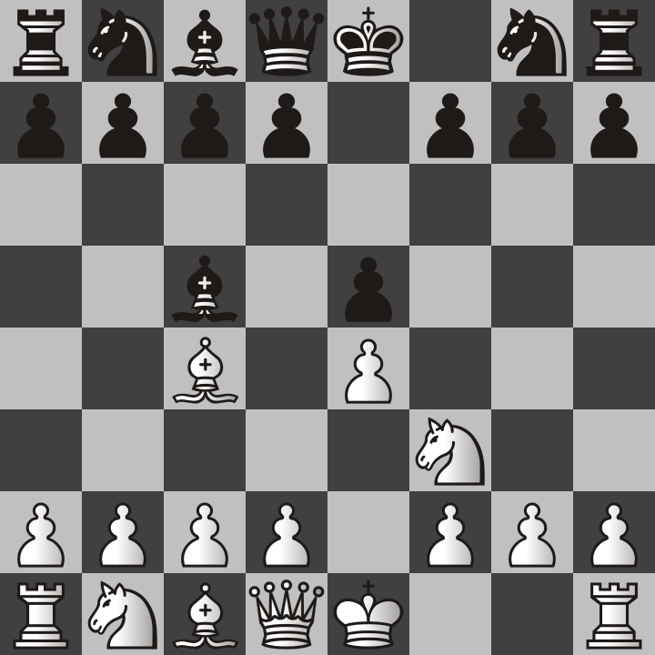

Why is this position good for white, you may ask. That’s because this knight move accomplishes several things at once.
1. It attacks the E5 pawn
2. It gets the knight out of the way so the king can castle
3. It prevents the black queen from going to H4 and trying to scholar’s mate white king on F2.
Based on my experience, what usually happens after this is that black will move their queen’s pawn to D6 and defend the E4 pawn. Then white will do the reverse and move their queen pawn to D3.
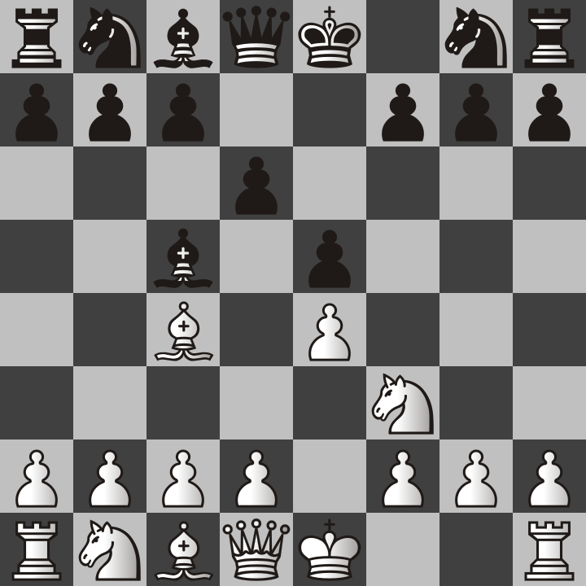
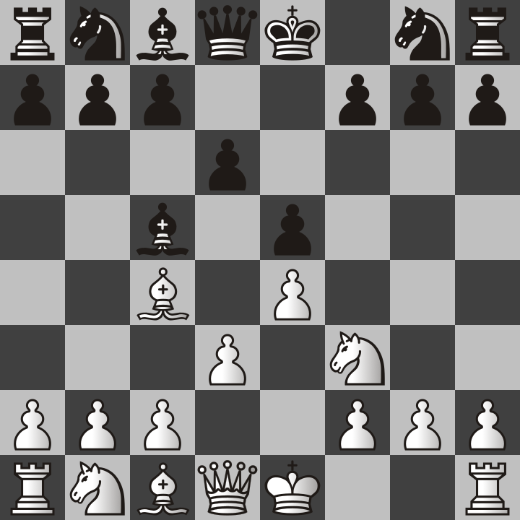

This also allows the bishops to move out that were previously blocked by those pawns. Black will most likely move the bishop to G4 and attack the knight.
This creates a problem for white because if they move the knight, the queen behind it will be captured. Because I value knights more than bishops, I recommend the following. After the bishop attacks the knight, sacrifice your bishop on F7 and put the king in check.

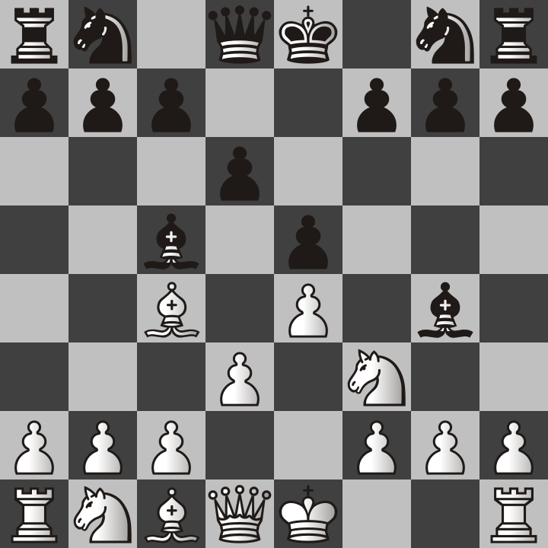
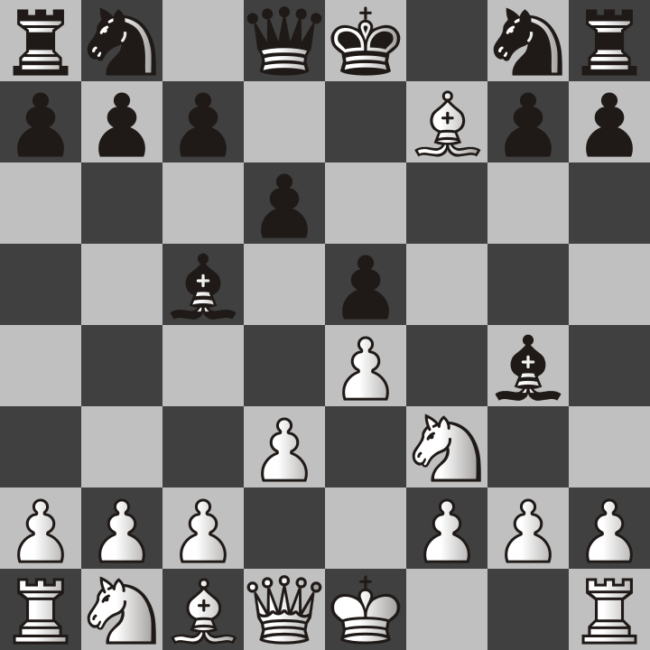

You may wonder why we would sacrifice a bishop. The idea behind this is for the king to capture it so that we lure the king to where the knight can put it in check!
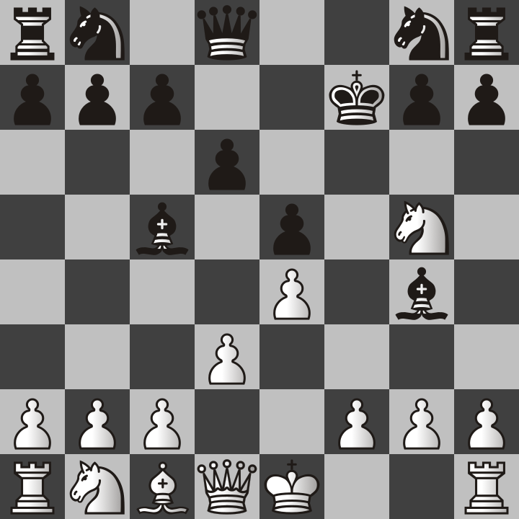
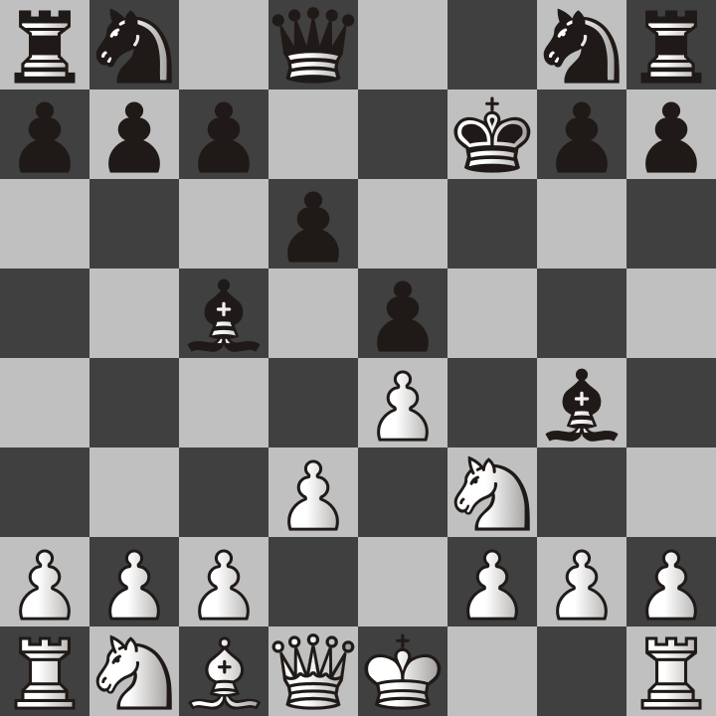

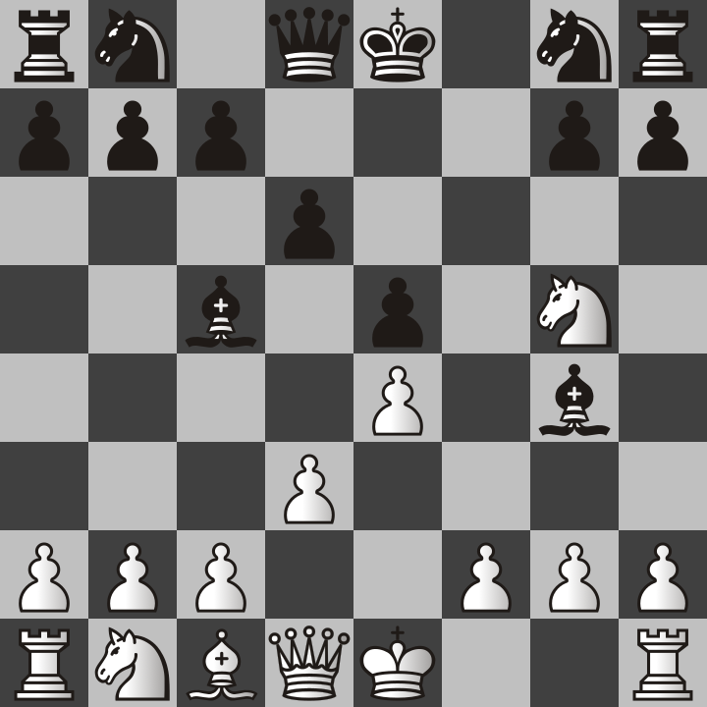
At this point, the king is forced to move again. No matter where the kind moves to, it will be white’s turn again and the white queen can capture the black bishop!
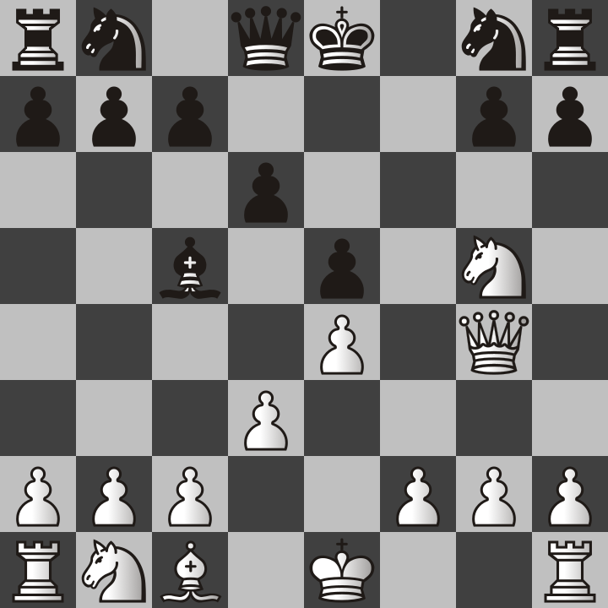

At this point, white has lost a bishop but they have also taken a bishop and a pawn. This strategy of sacrificing pieces to gain an advantage is one of my favorite things to do. It highlights the importance of being able to plan ahead in chess. With that being said, I will teach you my favorite opening for white, the Queen’s Gambit!

The Queen’s Gambit

The Queen’s Gambit sounds like a fancy name, and this name was used for a Netflix show as well. However, this opening was well known before people had televisions, computers, or the internet. The word “gambit” means sacrifice. In this opening white sacrifices a pawn with the hope of getting an advantage later. To some people, it also means a gamble because there is no way of knowing if it will work out the way you want depending on what your opponent does.
The opening starts with each side moving the pawn in front of their queen (where the gambit gets its name from.
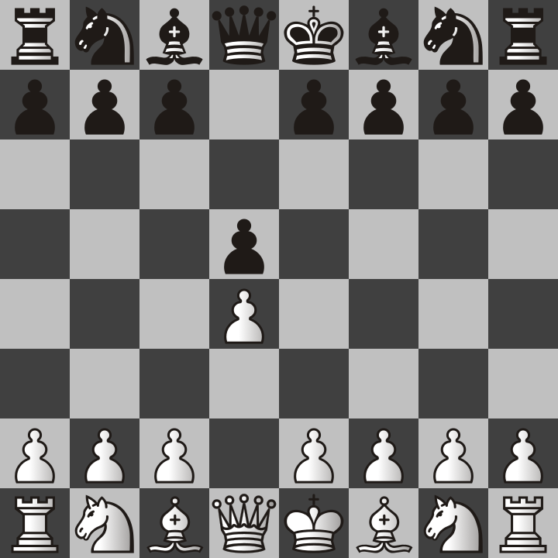

Next, white moves the pawn on C2 to C4.
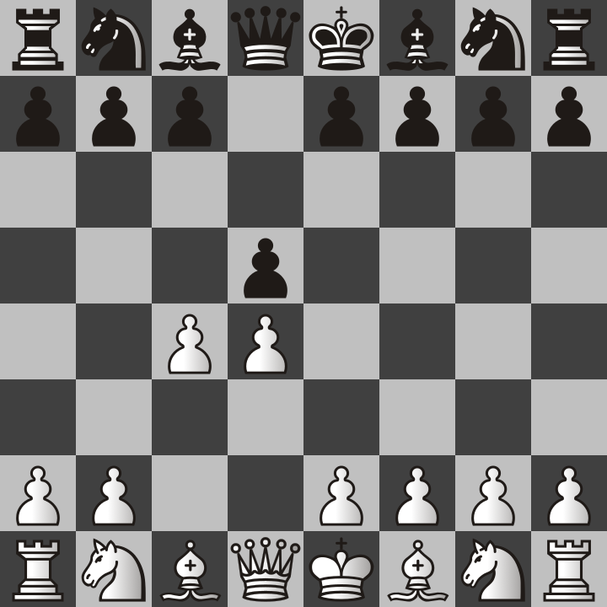

In this position, black’s pawn can capture the white pawn and yet it doesn’t appear that white can capture it back, at least not yet. If it does take the pawn, this is known as accepting the gambit. New players will more likely than not take this pawn if they don’t see the trap.
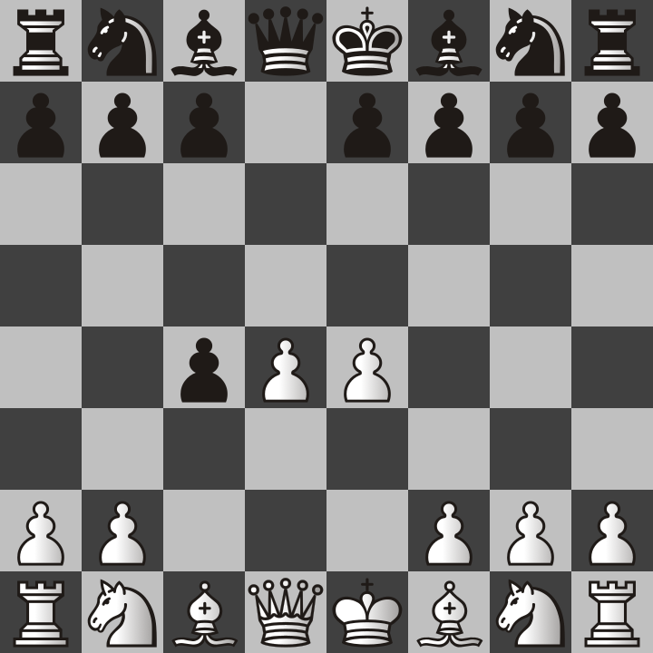

You see, the idea was to distract the pawn and move it away from the center so that white’s king pawn could move two squares forward. Also notice that the white bishop on F1 could also capture the black pawn on C4 next turn, but not so fast, first, black has to choose their next move. The only problem is that there really is no good way for black to stop white from taking their pawn with the bishop. If they try to protect it with another pawn, things can turn out badly. Sooner or later white will capture back the C4 pawn with the bishop and if black tries to stop it, they will only lose more pieces.

My best advice is that if you accept the Queen’s Gambit, also accept that you will lose this pawn and don’t let the sequence of the following page happen to you!

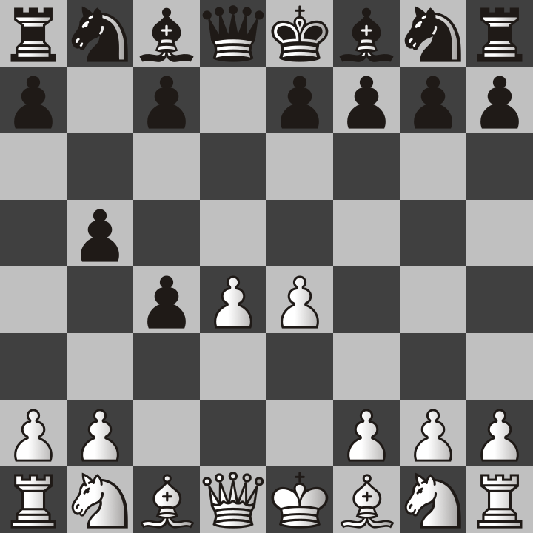
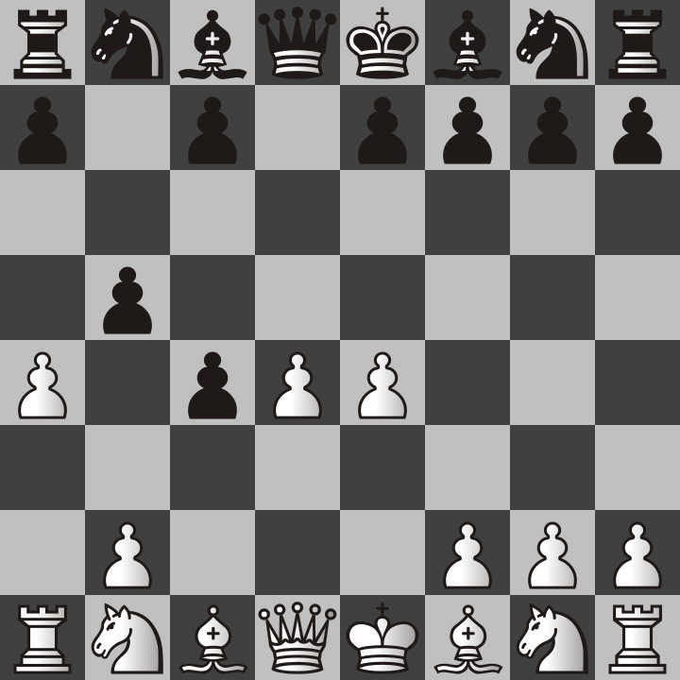

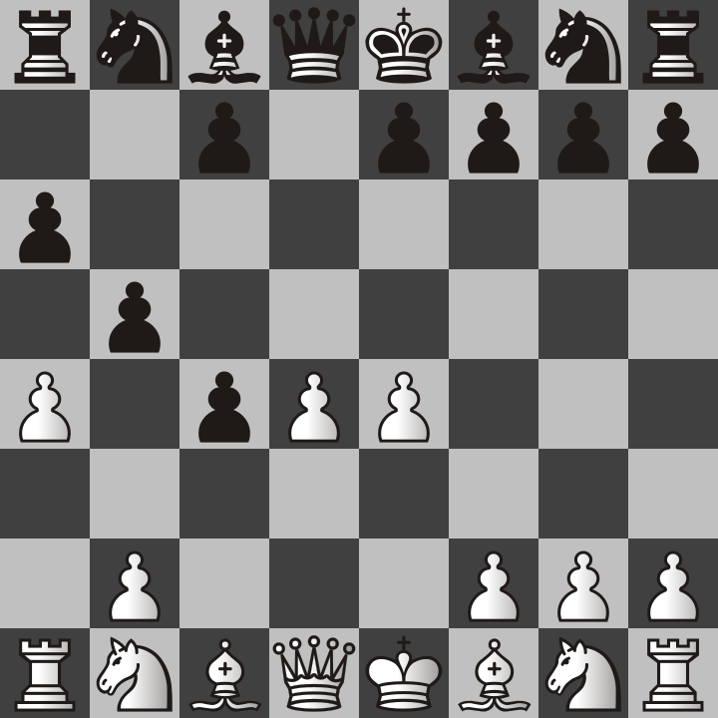
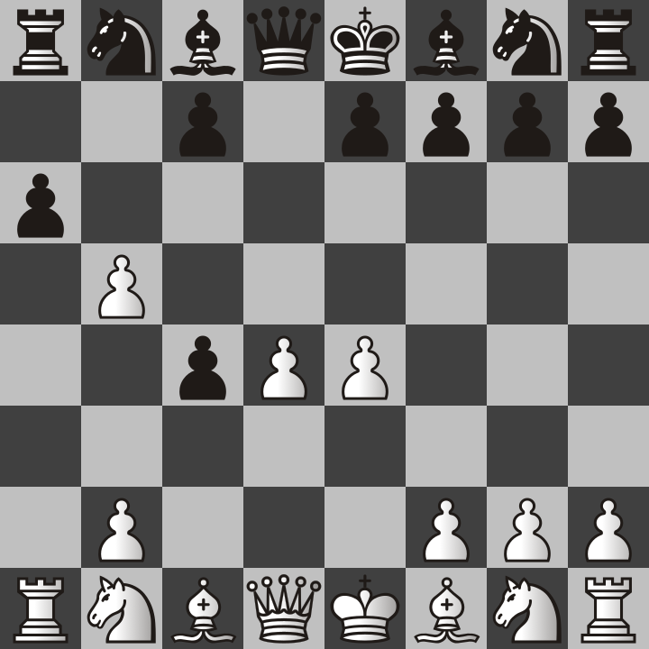

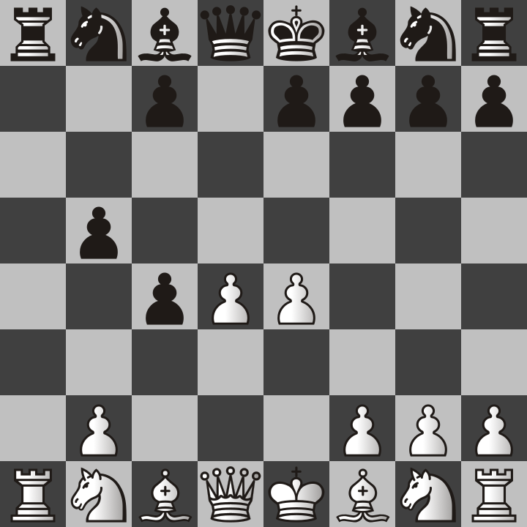
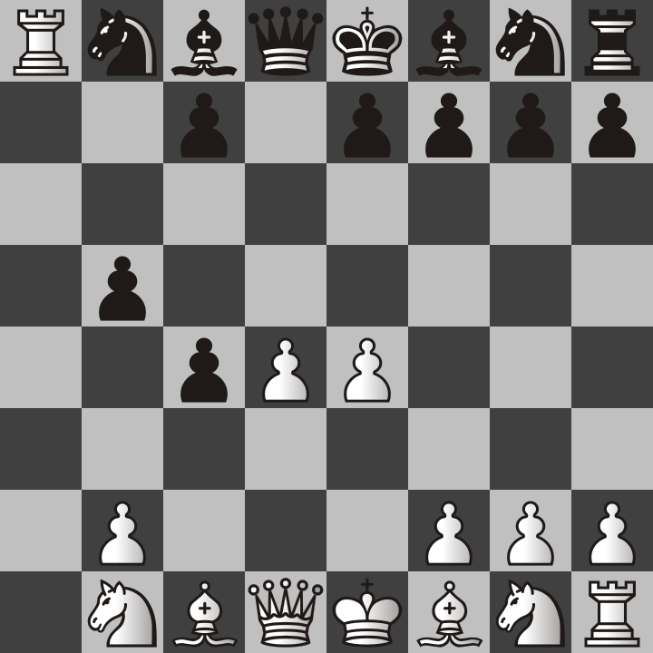

But actually, I would recommend against accepting the Queen’s Gambit entirely. If you are going to lose your pawn anyway, don’t waste time with that and instead move out other pawns depending on what pieces you plan to move. Below are the two most common responses to the Queen’s Gambit.

Queen’s Gambit Declined Slav Defense
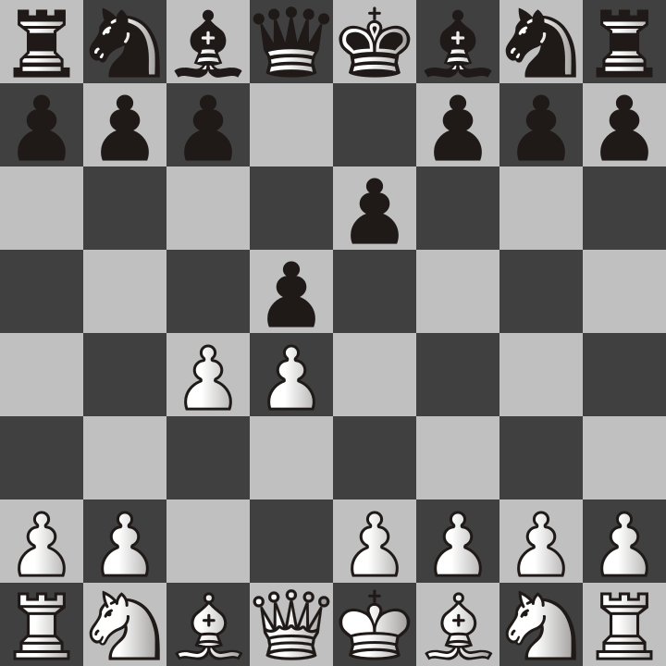
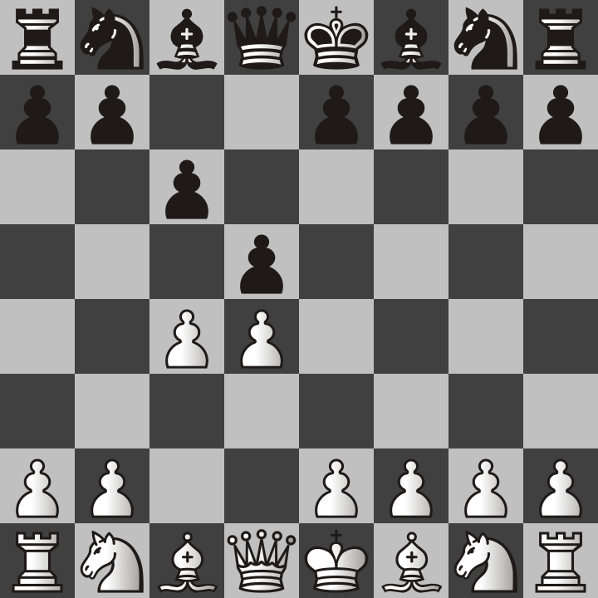

Both of these responses allow you to capture the white pawn back if it captures your D5 pawn. More importantly, you are getting pawns out of the way of your other pieces so that they can start attacking white. The Queen’s Gambit Declined is probably slightly better than the Slav Defense because moving the king’s pawn is just generally a great move because then black’s queen and dark squared bishop can move out diagonally and try to attack white.

But a final note is that accepting or declining the Queen’s Gambit does not lose for black by any means, but accepting it allows white to get both of their center pawns and allows them to start moving both bishops out very quickly. White already has the advantage, don’t give them more help if you are the black player. But if you are the white player, I have plenty of advice on what to do. However I may have to add more to this book later.

Now one thing you may have noticed is that the Queen’s Gambit started with moving the Queen’s Pawn (D4) instead of the King’s Pawn (E4) like in the previous example with the elaborate bishop sacrifice. Queen pawn openings are just far more fun to play because the game takes longer and my opponents get frustrated. E4 is better for quicker wins but is so cliché that I got tired of playing it and became a D4 player for my first move.

The London System

I am not the first person to say that the London System is a solid opening. In fact it’s probably the best opening to teach a beginner who has decided they like to open the game with D4. The first move will always be D4.

If you are the white player, you move first and therefore will always have the option of moving to D4. But the London System is actually quite unique in that your goal is not an early attack but the goal is to build a defensive structure. Look at the following picture.
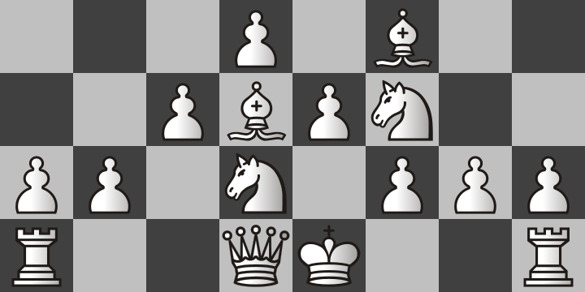
It takes a total of 7 moves to achieve this setup but it can usually be done quite easily no matter what black does. If you don’t get this position on your side because you had a chance to take your opponent’s pieces because they made bad moves, then that should take priority over building this. For example, suppose that your opponent moves their king’s pawn two squares forward to E5, then just take it with your pawn!
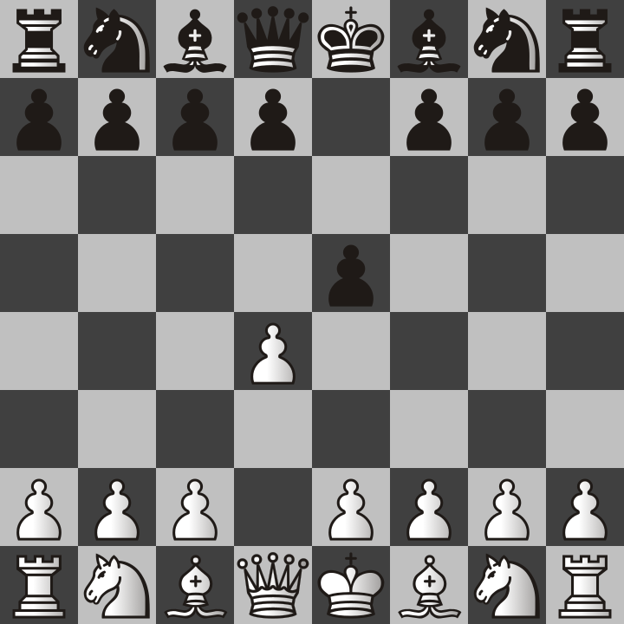
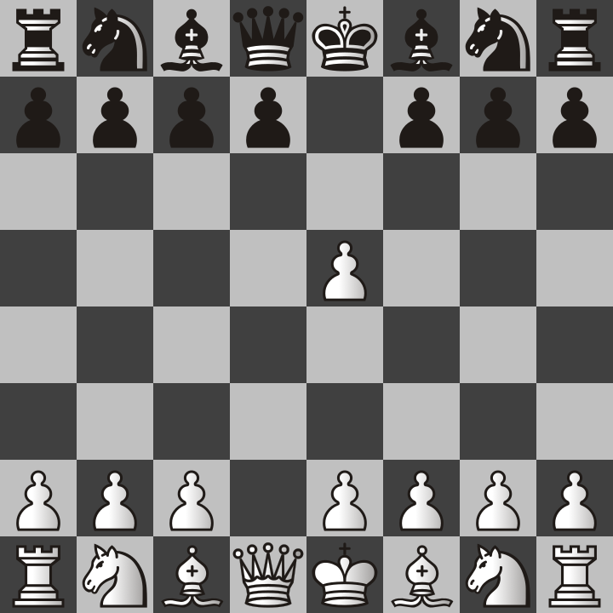

It’s totally easy to see how a player might be used to moving their king’s pawn two squares and might mistakenly let white’s D4 pawn take it. This completely disabled black’s development besides costing them a pawn. They can’t move their knight to F6, nor can they move the pawn in front of their queen either one or two spaces (because of en passant rule). If black makes this mistake, then they already have a huge disadvantage. This is not like the Queen’s Gambit because there is no advantage to offering white a free pawn. If black does this, then take that pawn and then build the rest of the London Fortress even though there will be a missing pawn at the head of the pyramid of pawns.
But most of the time, your opponent will not make a mistake as bad as the previous example. They will most likely do something smarter just as knight to F6.
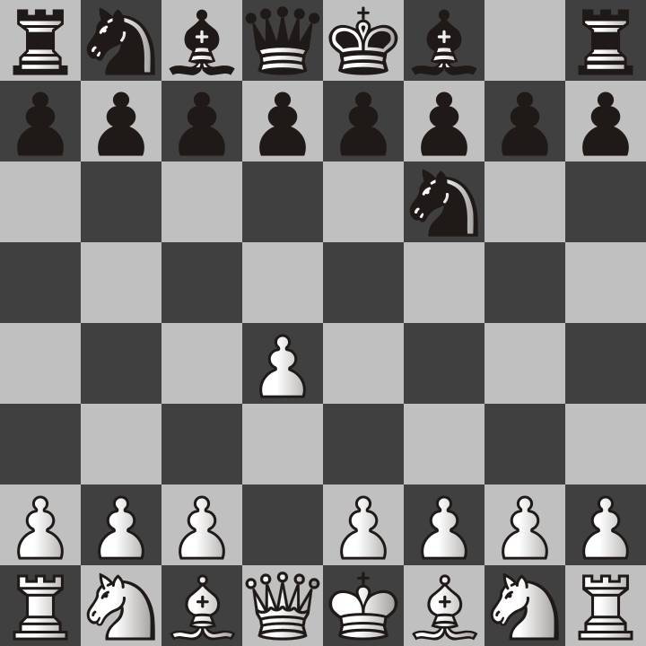

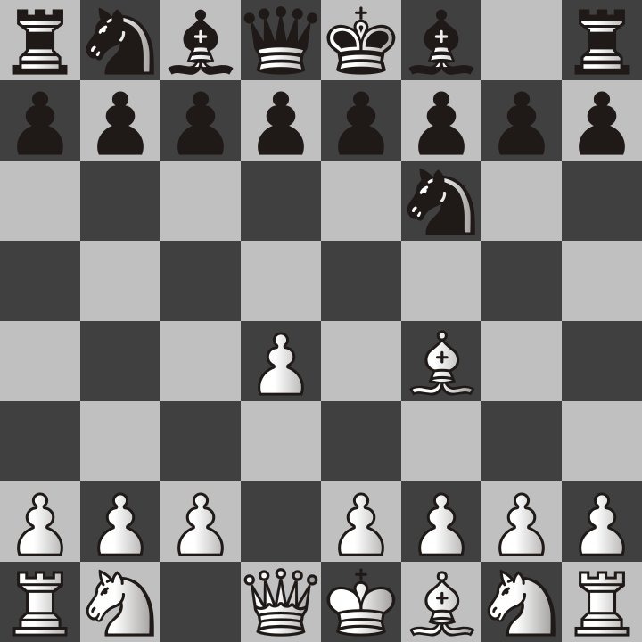
In this position, we see that the black knight is trying to prevent our king’s pawn to e4. That’s totally fine because that is not what we will do in the London system. We will continue to build our setup. In this position we should next move the bishop to F4.

It’s worth mentioning that bishop to F5 would also be a good move, and would be called the Trompowsky attack. However, since I am teaching the London System, we will stick with F4 for now.
Because of the fact that we have disabled the enemy king’s pawn from moving two squares, most players will instead move their queen’s pawn two squares instead. Remember, moving the pawns in front of the king or queen is almost always a good idea. With that in mind, our next move should be pawn to E3 because this is the next step in building the pawn pyramid, and it also adds an extra defender to the E4 pawn and Bishop.
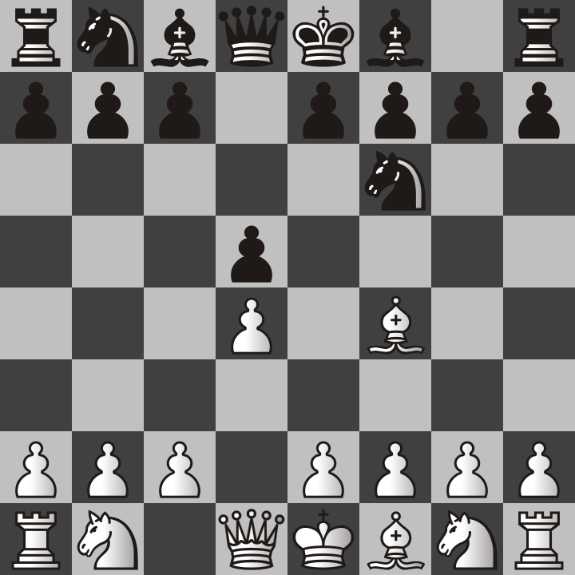
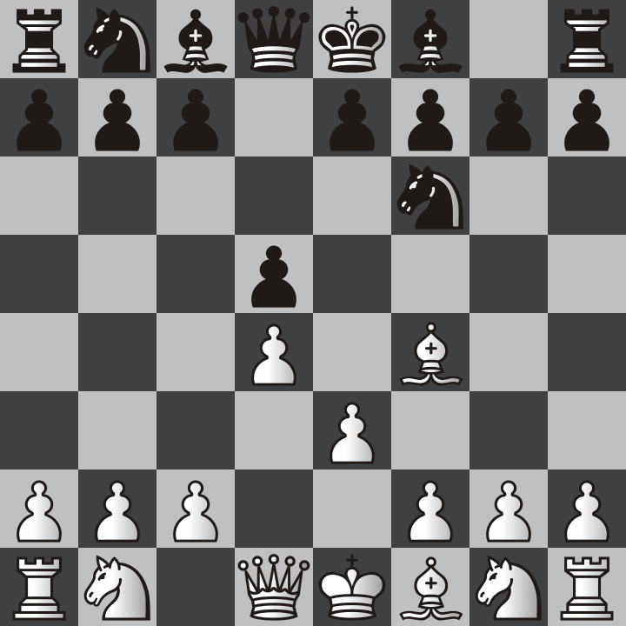

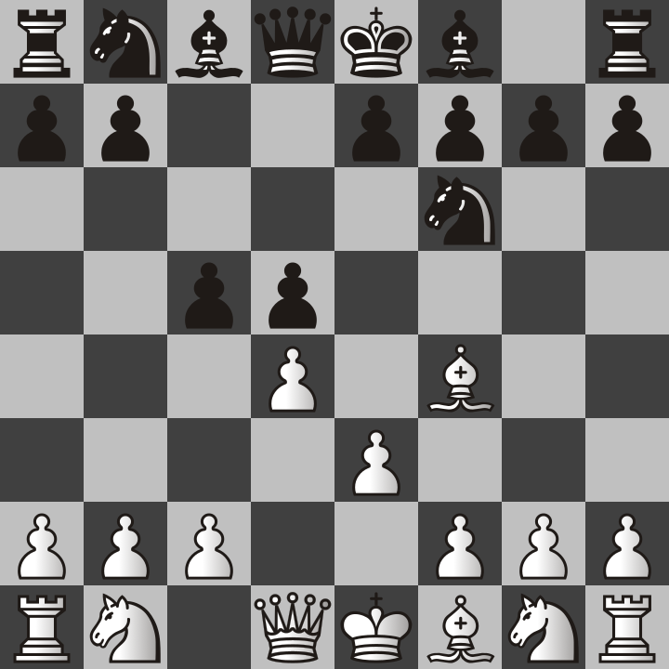
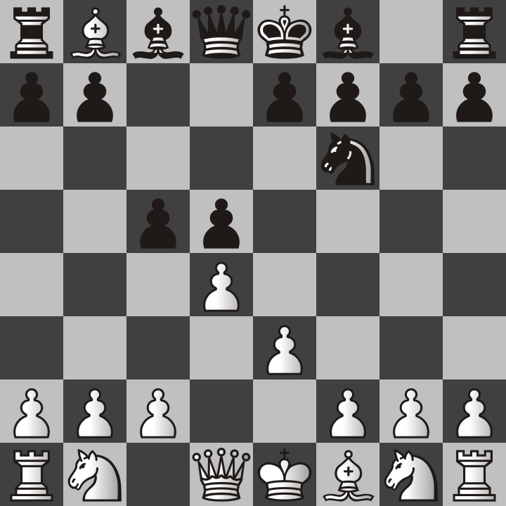
Keep in mind that this is still early in the game and that chess openings only take you so far. However, white has a really good winning chance in this setup. For example, black may try to offer the black version of the Queen’s Gambit by pawn to C5. However, doing so allows us to take their knight on B8!
The rook can take our bishop but we have eliminated one of the enemy knights. You may be wondering, why sacrifice the bishop to take down a knight? The reason I do this is because in my experience, knights are better than bishops. Each chess player has different opinions on this, but here it my own reasoning on why knights are more powerful than bishops.

Two knights can defend each other, unlike bishops which are always on different colored squares.
Knight attacks cannot be blocked, they are therefore better for checkmating in many cases I have seen.
Knights look like horses, which are my favorite animal. I prefer to protect my horses.

Maybe you disagree with me, in case you would not follow my advice. However stay with me and I think you will see that knights are worth protecting and that it is often worth losing a bishop to get rid of an enemy knight.

So far, all of what I have talked about so far is openings that white chooses to play. If you are the black player, what should you do? For one thing, you can expect that white will most likely play E4 for their first move, so I will cover the Caro Cann and the French Defense

To be continued!

